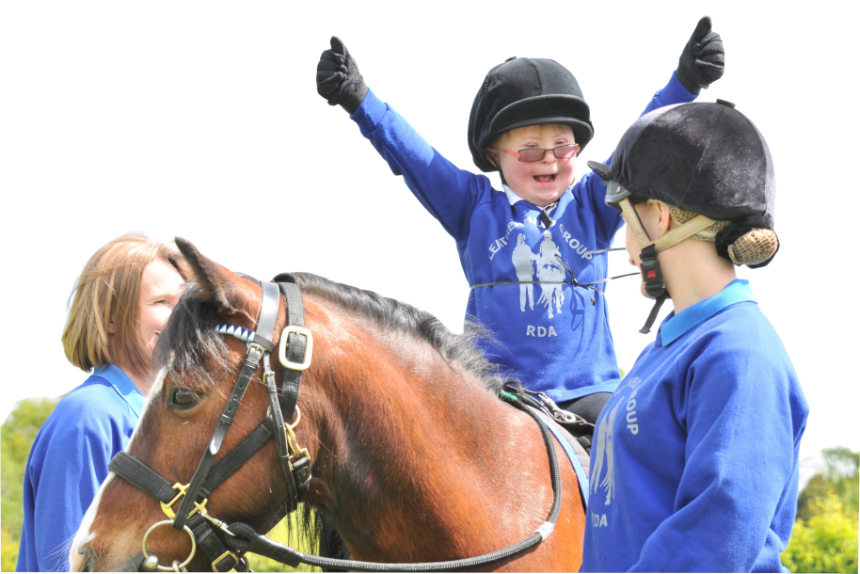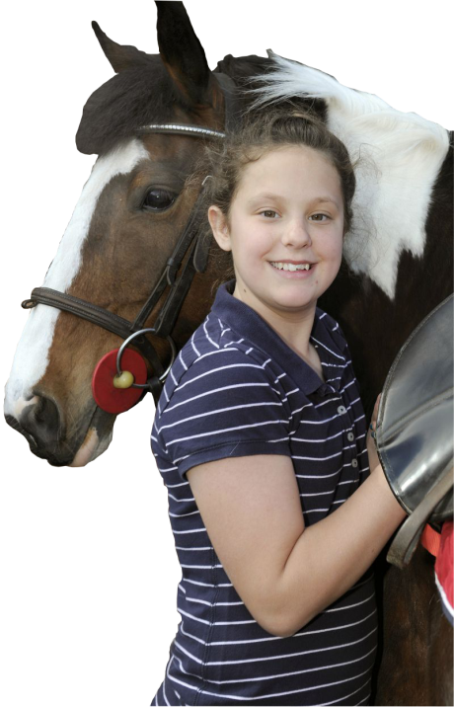

**RDA National Office:**

Laura Cartwright lcartwright@rda.org.uk **01926 476302**

Marisa Bretherton-Mackay [marisa@rda.org.uk](mailto:marisa@rda.org.uk) **01926 405973**

**Helplines:**

NSPCC Child Protection Helpline **0808 800 5000**

Childline **0800 1111**

Family Lives **0808 800 2222**

NAME: Jacky Nuth & Suzanne Stratford

TELEPHONE: 01420 375767

RIDE DAYS: Monday to Saturday

**GROUP**

**SAFEGUARDING OFFICERS**

